In [2]:

#Case Study: Testing Hypothesis

#Hypothesis: Articles about Climate Change are more likely to be published by "Liberal" sources

import pandas as pd

import numpy as np

import string

import re

import matplotlib.pyplot as plt

from collections import Counter

In [3]:

#Step 1: Load data into a dataframe

addr1 = "data/articles1.csv"

articles = pd.read_csv(addr1)

In [4]:

#Step 2: check the dimension of the table/look at the data

print("The dimension of the table is: ", articles.shape)

The dimension of the table is: (50000, 10)

In [5]:

#Display the 1st five rows of data

print(articles.head(5))

Unnamed: 0 id title \

0 0 17283 House Republicans Fret About Winning Their Hea...

1 1 17284 Rift Between Officers and Residents as Killing...

2 2 17285 Tyrus Wong, ‘Bambi’ Artist Thwarted by Racial ...

3 3 17286 Among Deaths in 2016, a Heavy Toll in Pop Musi...

4 4 17287 Kim Jong-un Says North Korea Is Preparing to T...

publication author date year month \

0 New York Times Carl Hulse 2016-12-31 2016.0 12.0

1 New York Times Benjamin Mueller and Al Baker 2017-06-19 2017.0 6.0

2 New York Times Margalit Fox 2017-01-06 2017.0 1.0

3 New York Times William McDonald 2017-04-10 2017.0 4.0

4 New York Times Choe Sang-Hun 2017-01-02 2017.0 1.0

url content

0 NaN WASHINGTON — Congressional Republicans have...

1 NaN After the bullet shells get counted, the blood...

2 NaN When Walt Disney’s “Bambi” opened in 1942, cri...

3 NaN Death may be the great equalizer, but it isn’t...

4 NaN SEOUL, South Korea — North Korea’s leader, ...

In [6]:

#what type of variables are in the table

print("Describe Data")

print(articles.describe())

# This shows the statistics applied only to numeric features of the dataset.

Describe Data

Unnamed: 0 id year month url

count 50000.000000 50000.000000 50000.000000 50000.000000 0.0

mean 25694.378380 44432.454800 2016.273700 5.508940 NaN

std 15350.143677 15773.615179 0.634694 3.333062 NaN

min 0.000000 17283.000000 2011.000000 1.000000 NaN

25% 12500.750000 31236.750000 2016.000000 3.000000 NaN

50% 25004.500000 43757.500000 2016.000000 5.000000 NaN

75% 38630.250000 57479.250000 2017.000000 8.000000 NaN

max 53291.000000 73469.000000 2017.000000 12.000000 NaN

In [7]:

print("Summarized Data on features of object type ")

print(articles.describe(include=np.object))

Summarized Data on features of object type

title publication \

count 50000 50000

unique 49920 5

top The 10 most important things in the world righ... Breitbart

freq 7 23781

author date content

count 43694 50000 50000

unique 3603 983 49888

top Breitbart News 2016-08-22 advertisement

freq 1559 221 42

In [8]:

#display length of data or number of rows

print(len(articles))

50000

In [9]:

#display publishers (publications)

print(articles.publication.unique())

['New York Times' 'Breitbart' 'CNN' 'Business Insider' 'Atlantic']

In [10]:

#display min, max of years published

print(articles['year'].min())

print(articles['year'].max())

print("\n")

#display how many articles from each year

print(articles['year'].value_counts())

2011.0

2017.0

2016.0 28451

2017.0 17908

2015.0 3326

2013.0 212

2014.0 76

2012.0 26

2011.0 1

Name: year, dtype: int64

In [11]:

#Step 3: Create some bar charts to show articles

#display bar chart of articles sorted by Publication Name

ax = articles['publication'].value_counts().sort_index().plot(kind='bar', fontsize=14, figsize=(12,10))

ax.set_title('Article Publication\n', fontsize=20)

ax.set_xlabel('Publication', fontsize=18)

ax.set_ylabel('Count', fontsize=18);

plt.show()

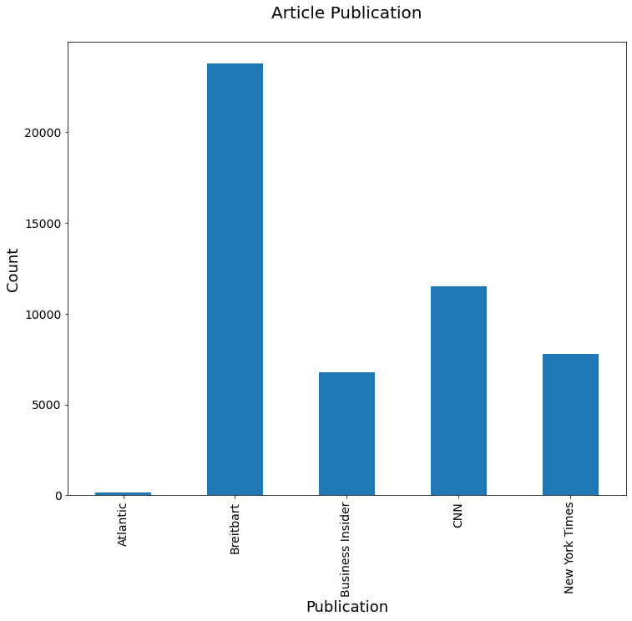

In [12]:

#display bar chart of articles sorted by counts

ax = articles['publication'].value_counts().plot(kind='bar', fontsize=14, figsize=(12,10))

ax.set_title('Article Count - most to least\n', fontsize=20)

ax.set_xlabel('Publication', fontsize=18)

ax.set_ylabel('Count', fontsize=18);

plt.show()

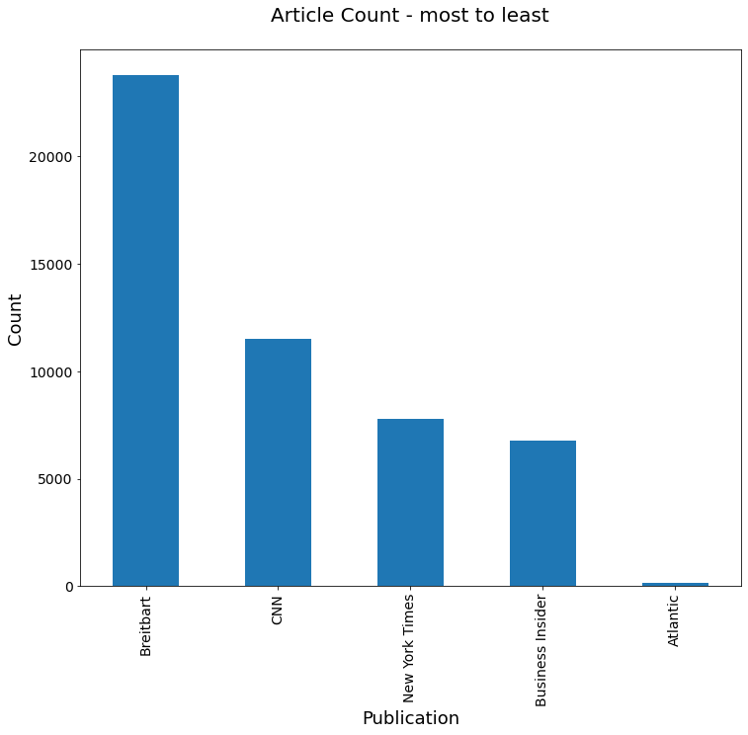

In [13]:

#Step 4: clean text: no punctuation/all lowercase

def clean_text(article):

clean1 = re.sub(r'['+string.punctuation + '’—”'+']', "", article.lower())

return re.sub(r'\W+', ' ', clean1)

In [14]:

articles['tokenized'] = articles['content'].map(lambda x: clean_text(x))

print("clean text: ",articles['tokenized'].head())

clean text: 0 washington congressional republicans have a ne...

1 after the bullet shells get counted the blood ...

2 when walt disneys bambi opened in 1942 critics...

3 death may be the great equalizer but it isnt n...

4 seoul south korea north koreas leader kim said...

Name: tokenized, dtype: object

In [15]:

#look at mean, min, max article lengths

articles['num_wds'] = articles['tokenized'].apply(lambda x: len(x.split()))

print("Mean: ",articles['num_wds'].mean())

print("Min: ",articles['num_wds'].min())

print("Max: ",articles['num_wds'].max())

Mean: 636.26046

Min: 0

Max: 24736

In [16]:

#Step 5: remove articles with no words

len(articles[articles['num_wds']==0])

articles = articles[articles['num_wds']>0]

print("new mean: ",articles['num_wds'].mean())

print("new min: ",articles['num_wds'].min())

new mean: 637.0886752778612

new min: 1

In [17]:

#Step 6: Check for Outliers: show bar graph of outliers

ax=articles['num_wds'].plot(kind='hist', bins=50, fontsize=14, figsize=(12,10))

ax.set_title('Article Length in Words\n', fontsize=20)

ax.set_ylabel('Frequency', fontsize=18)

ax.set_xlabel('Number of Words', fontsize=18);

plt.show()

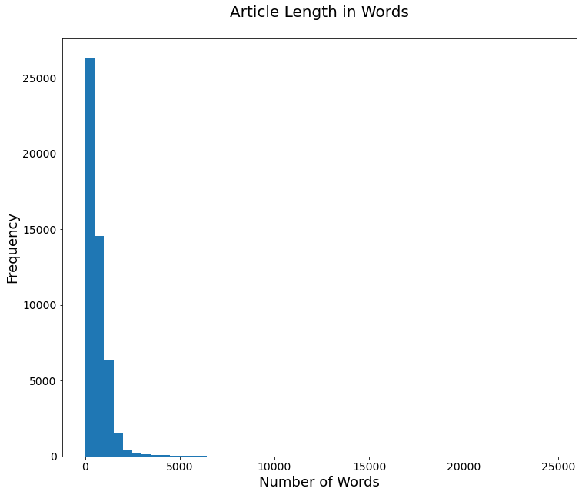

In [18]:

#Step 6: Check for Outliers: show bar graph of outliers

ax=articles['num_wds'].plot(kind='hist', bins=50, fontsize=14, figsize=(12,10))

ax.set_title('Article Length in Words\n', fontsize=20)

ax.set_ylabel('Frequency', fontsize=18)

ax.set_xlabel('Number of Words', fontsize=18);

plt.show()



In [ ]: